

**Next...**

In Year 3 children will represent numbers to 1000, use number lines to 1000, find 1, 10 and 100 more/less than any given number and count in 50s and 100s.

Year 2

Place Value

**Previously…**

In Year 1 children were counting forwards and backwards within 100, finding 1 more and 1 less than any given number and partitioning.

**Facts**

I can count objects to 100 by making 10s I can count in 2s, 5s and 10s

I can recognise tens and ones I can count in 3s

I can use a place value chart

I can partition numbers to 100

I can write numbers to 100 in words

I can write numbers to 100 in expanded form

I can locate and count in 10s on a number line

I can estimate numbers on a number line

I can compare objects and numbers

I can order objects and numbers

**Questions**

Do you notice a pattern with the numbers?

What do these numbers all end in?

What practical equipment is best for showing groups of 10?

How many tens are there?

How many ones are there?

What do <,> and = mean?

What is different about using base 10 to using place value counters?

Do the numbers in the sequence get larger or smaller?

**Vocabulary**

Hundreds, tens, ones

Zero

Place value

Greater than, less than

Order

Partition

Digit

Compare / order

Our Learning Keys

Place Value

Year 2

Weeks 1-4

**Image**

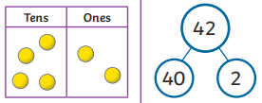 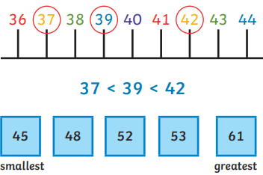

Maths

**Doors this will open…**

Data analysis

Statistician

Scientist

Engineer

Builder

**Links**

Art – patterns

English – common exception word (writing numbers in words)

Science – comparisons