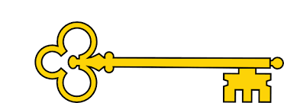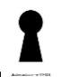

**Vocabulary**

Flat / Solid / Corner

Apex / Vertex / vertices

Side / Angle / Face

Curved / straight / round

Line of symmetry / pattern

Hexagon / pentagon / quadrilateral

Triangular prism / square based pyramid

**Questions**

What makes a shape 3D?

How do we know if a shape is 2D?

Can you name this 3D shape?

What is the same and what is different?

How could you sort the shapes?

What is a pattern?

What do you notice about this pattern?

What is the order of the shapes in the pattern?

**Facts**

I can recognise 2D and 3D shapes

I can count the sides and vertices on a 2D shape

I can draw 2D shapes

I can draw lines of symmetry on shapes

I can use lines of symmetry to complete shapes

I can sort 2D and 3D shapes

I can count the faces, edges and vertices on 3D shapes

I can make a pattern using 2D and 3D shapes

**Previously…**

In Year 1 children were taught to recognise and name 3D shapes as well as create patterns using both 2D and 3D shapes.

Year 2

Shape

**Next...**

In Year 3 children will learn about turns and angles. They will find right angles in shapes as well as compare and draw angles accurately. They will understand parallel and perpendicular and make their own 3D shapes

Year 2

Weeks 10 – 12

**Images**

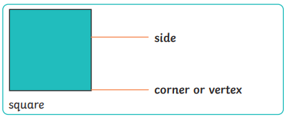 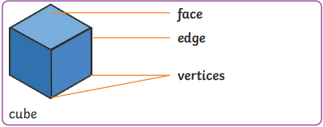 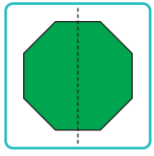

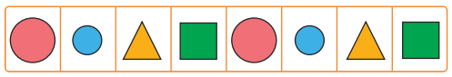

Shape

Our Learning Keys

Maths

**Doors this will open…**

Construction worker

Architect

Fashion designer

Plumber

Game developer

Engineer

**Links**

Art – patterns

DT – building