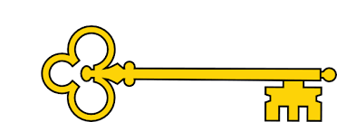

**Vocabulary**

Part whole model

Total / altogether / equals

Addition / add / plus / more

Subtract / take away / less / how many left

Number bonds

Fact family

Number sentence

**Questions**

What does whole mean?

What does part mean?

How can we represent the whole/parts?

Is the equals sign always at the end of a number sentence?

How can we count on to find the missing part?

What is the same and what is different about the calculations?

What strategy can we use to help us find the difference?

**Next...**

In Year 2 children will add and subtract 2 digit numbers (crossing 10’s)

**Facts**

I can name the parts and whole on a part whole model

I can write number sentences

I can complete an addition fact family

I can systematically solve number bonds to 10

I can solve number bonds to 10

I can add within 10

I can find a part on a part whole model

I can solve addition problems (within 10)

I can subtract to find a part

I can cross out / take away to subtract

I can subtract on a number line

**Images**

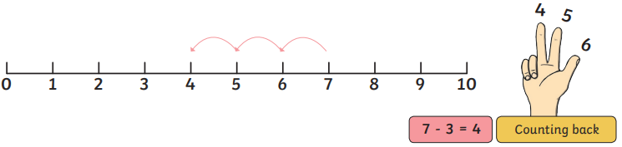 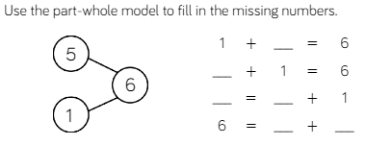

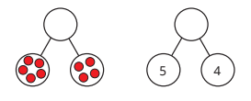 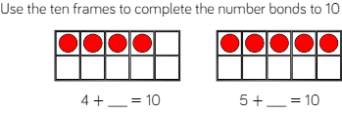

Addition and Subtraction (within 10)

Our Learning Keys

Year 1

Weeks 6-10

Maths

**Doors this will open…**

Data analysis

Statistician

Scientist

Engineer

Builder

**Links**

English – worded problems

PE – ordinal numbers (1st, 2nd, 3rd, etc)

Year 1

Addition and Subtraction (within 10)

**Previously…**

In EYFS children worked on number bonds to 5 and count groups to find a total