

Our Learning Keys

Place Value (within 10)

Year 1

Weeks 1-5

**Vocabulary**

Total / altogether

Greater than / fewer than

More / less / equal

One more / one less

Group / groups of

Sort / Compare

Representation

Count forwards / count backwards

**Questions**

How can they be sorted / grouped?

How many ways can we group them?

How many are there in total

Where can one more than ______ be found on a number track?

What does one more mean?

Will the number get bigger or smaller?

What does more/greater mean?

Where does the number line start?

**Images**

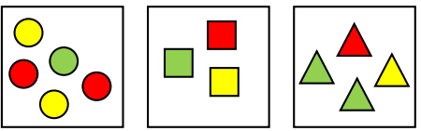 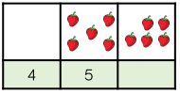 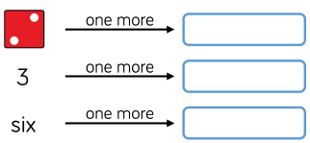

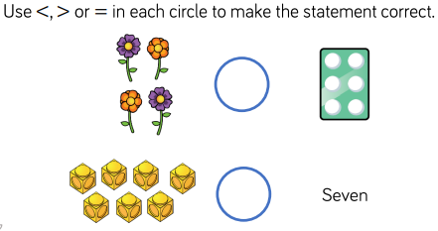 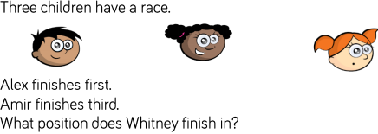 

Maths

**Doors this will open…**

Data analysis

Statistician

Scientist

Engineer

Builder

**Links**

Art – patterns

English – common exception words (writing numbers 1-10)

Science – comparisons

Year 1

Place Value

(Within 10)

**Next...**

In Year 2 children will be able to count, compare and represent numbers up to 100as well as use a place value chart

**Facts**

I can sort objects into groups I can compare numbers

I can count objects within 10 I can order objects and numbers

I can represent objects I can find one less

I can recognise numbers as words

I can count on from any number

I can find one more

I can count backwards within 10

I can find a number on a number line

I can compare groups by matching

I can say if a group is less than, greater than or equal

**Previously…**

In EYFS children worked on number recognition and counting