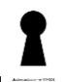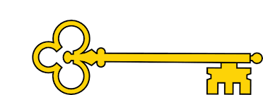

**Next...**

In Year 2 children will be able to count sides and vertices on 2D shapes as well as draw them. They will also understand lines of symmetry as well as count faces on 3D shapes.

**Previously…**

In EYFS children investigated how shapes can be combined to create new shapes. They also found 2D shapes within 3D shapes, including through printing or shadow play.

Year 1

Shape

**Facts**

I can recognise and name 3D shapes

I can sort 3D shapes

I can recognise and name 2D shapes

I can sort 2D shapes

I can make a pattern using 3D shapes

I can make a pattern using 2D shapes

**Questions**

What makes a shape 3D?

How do we know if a shape is 2D?

Can you name this 3D shape?

What is the same and what is different?

How could you sort the shapes?

What is a pattern?

What do you notice about this pattern?

What is the order of the shapes in the pattern?

**Vocabulary**

2D shapes

Square, circle, triangle, pentagon, hexagon, rectangle,

3D shapes

Cube, cylinder, cuboid, pyramid, cone, sphere

Patterns

**Images**

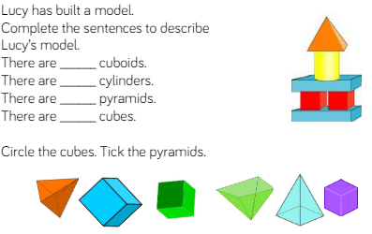 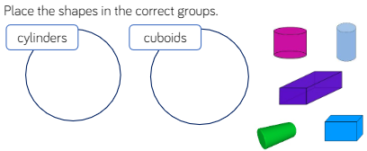 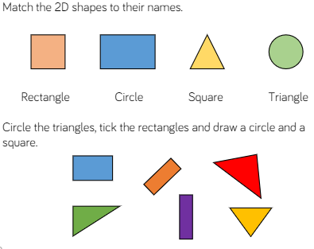

Shape

Our Learning Keys

Year 1

Week 11

Maths

**Doors this will open…**

Construction worker

Architect

Fashion designer

Plumber

Game developer

Engineer

**Links**

Art – patterns

DT – building