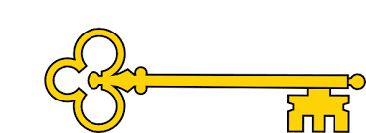

Learning objectives

 Predict a characters feelings based on what’s been read so far

 Understand the use of speech bubbles

 Draw upon knowledge of vocabulary in order to understand

the text

 Discuss the intentions of the author

 Write a sentence using an exclamation mark

 Make a prediction based on what’s been read so far

 Explain your preferences, thoughts and opinions about the

text.

 Explain your preferences, thoughts and opinions about the

text.

 Create a story retell

 Blurb and Main Themes

“We’ll get that penguin”, said Slasher. “Yeah. we’ll get him”, said Sluggit.

Penk the penguin is stranded on Shark Island. How will he ever get home to Penguin Bay? The shark twins, Slasher and Sluggit, will gobble him up if he trys to get home. There is nothing they like to eat more than a tasty penguin. Will Penk’s great uncle and the penguin rescue ship save him in time?

`

Links

  Science

 PSHE

Literacy

Images

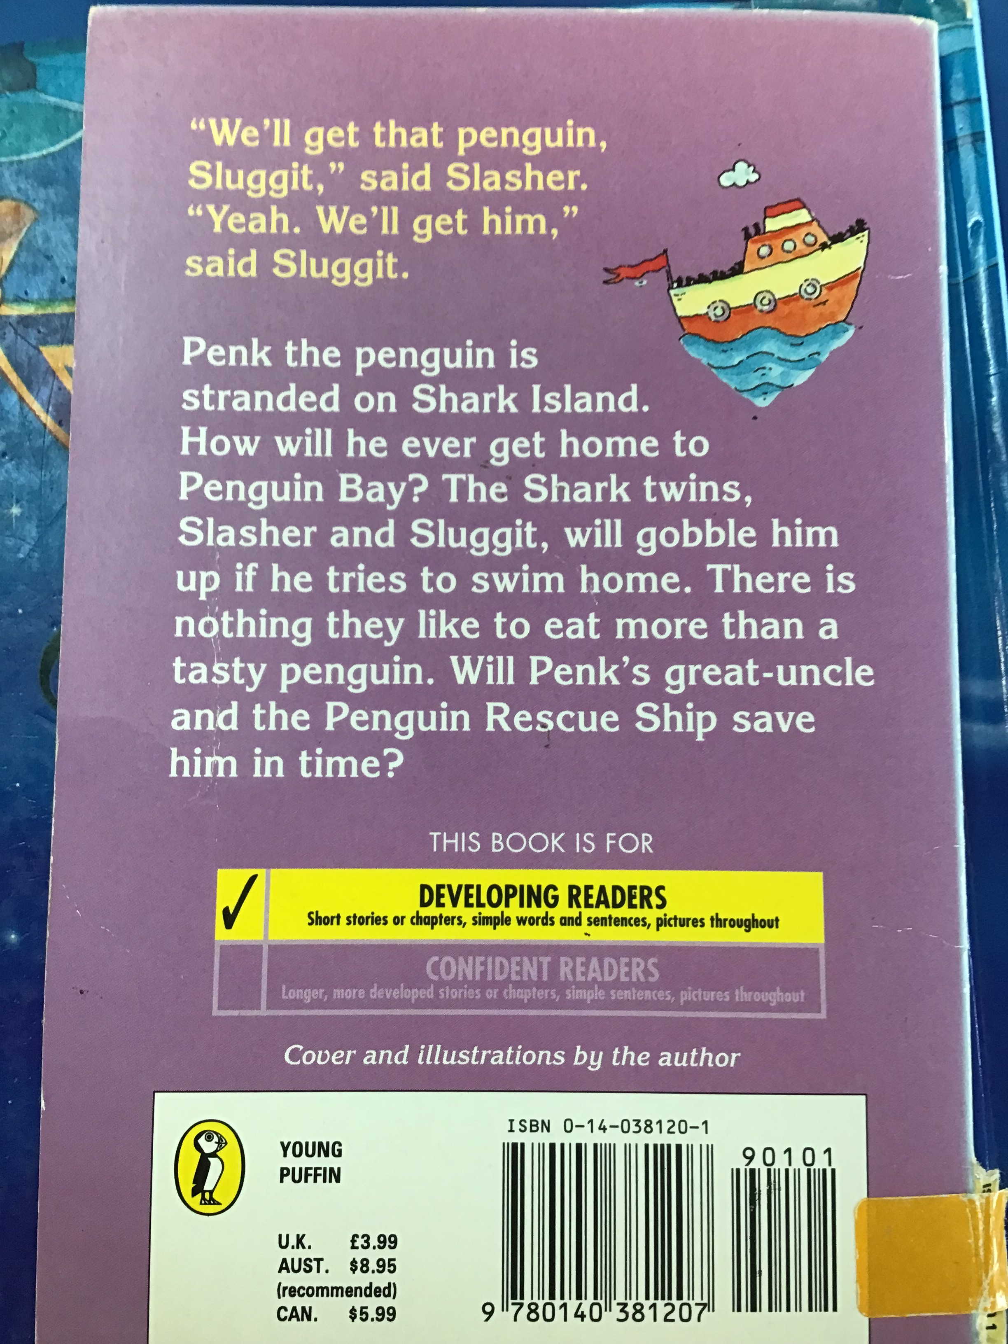

`

 Vocabulary

 Snap

 Crash

 Thump

 Exclamation

Mark

 Onomatopoeia

Reading Skills

V – Vocabulary

I - Inference

P – Prediction

E - Explain

R – Retrieval

S - Sequence

Fiction. Shark Island Angie Sage

Reading Skills

**Doors this will open…**

 Author

Illustrator

Publisher

Year 1

Autumn 2

**Next**

I’m a little reindeer

Unknown author

**Previously**

Bugs

Usbourne readers

**Now**

Shark Island

Angie Sage

Our Learning Keys