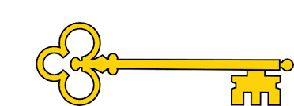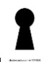

Non- Fiction. My clever brain Lauren Taylor

Reading Skills

Images

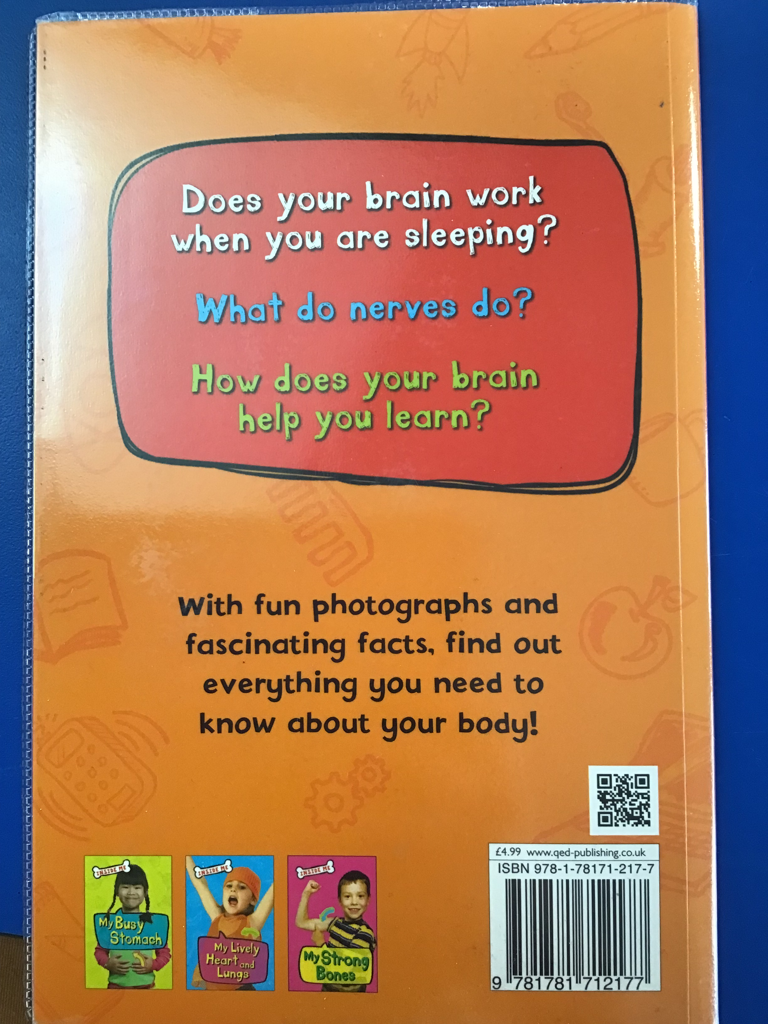

`

 Blurb and Main Themes

Does your brain when you are sleeping?

What do nerves do?

How does your brain help you learn?

With fun photographs and fascinating facts, find out everything you need to know about your body!

`

Reading Skills

V – Vocabulary

I - Inference

P – Prediction

E - Explain

R – Retrieval

S - Summarise

**Doors this will open…**

 Author

Neurobiology

Nutritionist

Links

 Science

 PSHE

 PE

Year 1

Autumn 1

Learning objectives

 Identify and explain key features of a non-fiction text

Begin to understand similes

 Explain your preferences, thoughts and opinions about the text

 Use key words from the text

 Understand how a glossary works

 Vocabulary

 Brain

 Nerves

 Skull

 Spinal cord

**Next**

Aladdin

Disney

**Previously**

**Now**

My clever brain

Lauren Taylor

Our Learning Keys