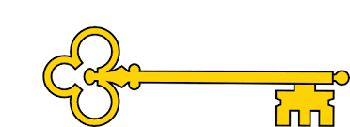

 Blurb and Main Themes

‘I’m a little reindeer’ is a catchy Christmas time poem for children.

`

Learning objectives

 Rhyming words

 Recite a poem off by heart

Links

  RE

Literacy

Images

`

 Vocabulary

 Christmas

 Sleigh

Reading Skills

V – Vocabulary

I - Inference

P – Prediction

E - Explain

R – Retrieval

S - Sequence

Poetry. I’m a little reindeer Unknown author.

Reading Skills

**Doors this will open…**

 Author

Illustrator

Publisher

Poet

Year 1

Autumn 2

**Next**

The Genie

Mary Hooper

**Previously**

Shark Island

Angie Sage

**Now**

I’m a little reindeer

Unknown author

Our Learning Keys