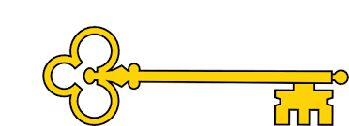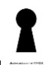

Learning objectives

 Recap the differences between fiction + non-

fiction

 How captions are used

 Sequence key events

 Understand the purpose of a heading

 Sequence the key events

 Share thoughts and opinions about the text

 Understand the role of a glossary

 Make a prediction based on what’s been read

so far

 Understand the role of an index

 Blurb and Main Themes

There are thousands and thousands of different bugs in the world. Find out all kinds of creepy crawly things about them in this fascinating book. Bugs is part of an exciting series of books to read on their own. The easy-to-read text has been specially written with the help of a reading expert.

`

Links

  Science

 PSHE

Literacy

Geography

Images

`

 Vocabulary

 Non- Fiction

 Glossary

 Index

 Exoskeleton

 Egg sac

 Prey

 Camouflage

 Lavae

 Wing cases

 Pupa

Reading Skills

V – Vocabulary

I - Inference

P – Prediction

E - Explain

R – Retrieval

S - Sequence

Non-Fiction Bugs Usbourne readers

Reading Skills

**Doors this will open…**

 Author

Illustrator

Publisher

Entomologist

Year 1

Autumn 2

**Next**

Shark Island

Angie Sage

**Previously**

The Wind

Christina Rossetti

**Now**

Bugs

Usbourne readers

Our Learning Keys