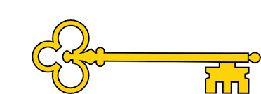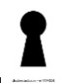

Learning objectives

 Discuss the text type.

 Make inferences from the text

  Explain which vocabulary best describes the mood.

  Who is your favourite character and why?

 Make a prediction on what has been read so far.

 Share own opinions.

Explain your own preferences, thoughts and opinions about the text.

Sequence the key events of the story.

Links

 Art

 Drama

Literacy

PSHE

 Blurb and Main Themes

A kindhearted street urchin and a power- hungry Grand Vizier vie for a lamp that has the power to make their deepest wishes come true.

`

Images

`

 Vocabulary

 Alluring

 Palace

 Bazaar

 Sultan

 Urchin

 Vizier

Reading Skills

V – Vocabulary

I - Inference

P – Prediction

E - Explain

R – Retrieval

S - Sequence

Fiction. Aladdin Disney

Reading Skills

**Doors this will open…**

 Author

Illustrator

Animator

Screen writer

Voice actor

Year 1

Autumn 1

**Next**

The Wind

Christina Rossetti

**Previously**

My clever brain

Lauren Taylor

**Now**

Aladdin

Disney

Our Learning Keys